Magic School Bus Electricity Lab Guide
Get ready to take chances, make mistakes, and get messy! Guide and materials for 4 stations (10 setups each).

Lab 1: Simple Circuits ("Gets Charged")
Objective: Students will create a closed loop to light a miniature bulb.

Material | Qty (10x) | Notes
Batteries (AA/D) | 10 | 1 per setup
Battery Holders | 10 | 1 per setup
Small Light Bulbs | 10 | 1.5V-3V miniature bulbs
Bulb Holders | 10 | To match bulbs
Alligator Clip Wires | 30 | 3 per setup
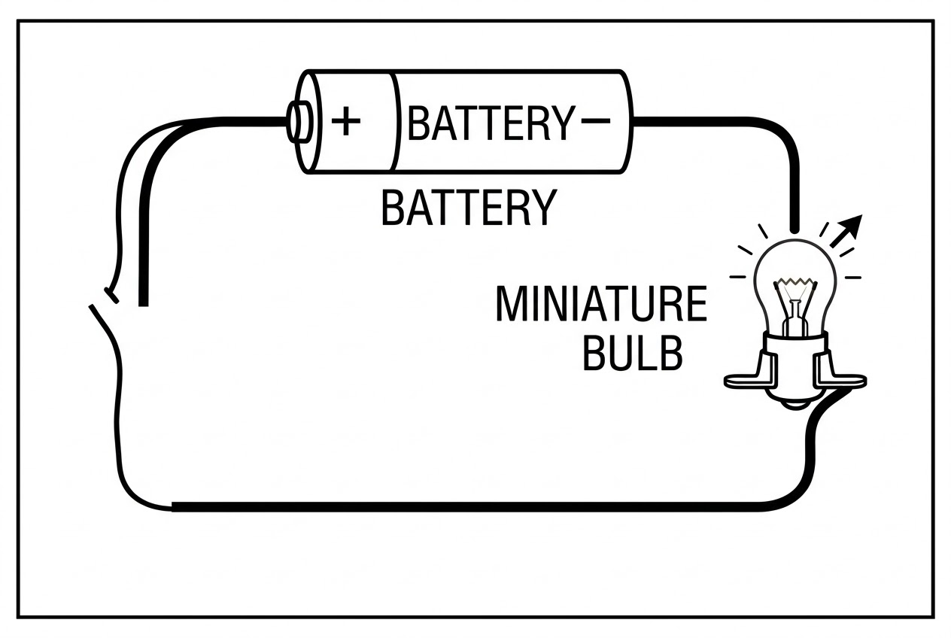

Lab 2: Conductors & Insulators
Objective: Test various household items to see if they allow electricity to flow.

Material | Qty (10x) | Notes
Test Material Bags | 10 | Coin, paperclip, rubber band, spoon
Existing Circuit Setup | 10 | Reuse from Lab 1
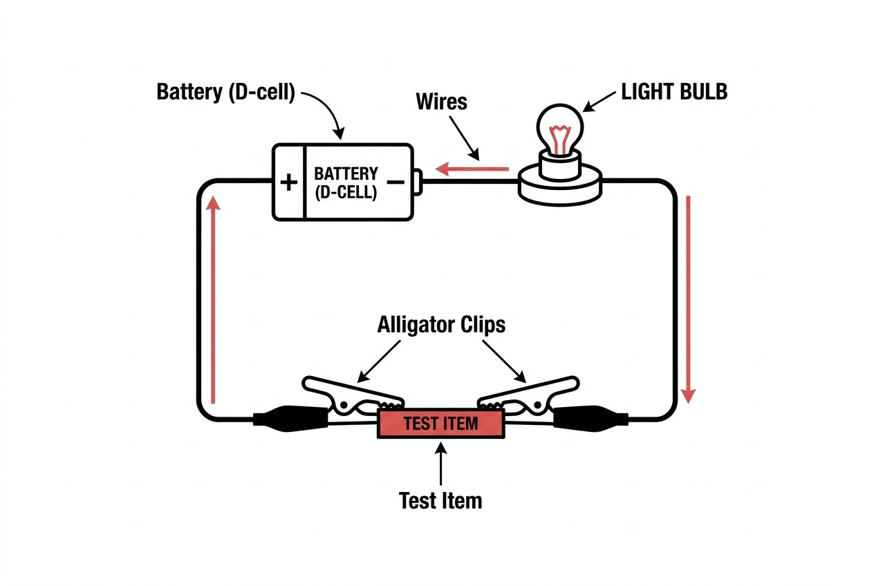

Lab 3: Electromagnets ("Electric Field Trip")
Objective: Use an electrical current to create a magnetic field around an iron core.

Material | Qty (10x) | Notes
Large Iron Nails | 10 | 1 per setup
Copper Wire | 10 strands | Thin/insulated, ~3 ft per setup
D Batteries | 10 | Stronger battery needed
Metal Paperclips | 10 small boxes | To test magnetic strength
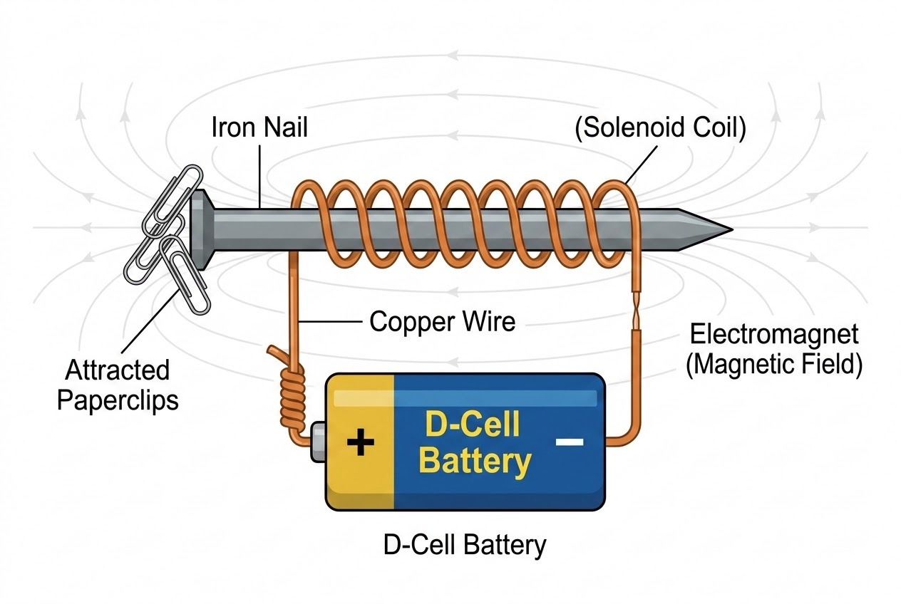

Lab 4: Static Electricity ("Jumping into Electricity")
Objective: Generate a static charge through friction to attract lightweight objects.

Material | Qty (10x) | Notes
Balloons | 10 | To generate static charge
Wool or Felt Pieces | 10 | To rub against balloons
Tissue Paper Chunks | 10 small bowls | To attract with static balloon
